**POWER BI ASSIGNMENT-14**

**Topic –** Calculated columns.

**Exercise –** Use the RELATED function to combine fields from four tables.

Q1. Create a new POWER BI report and load the data from the Excel file provided.

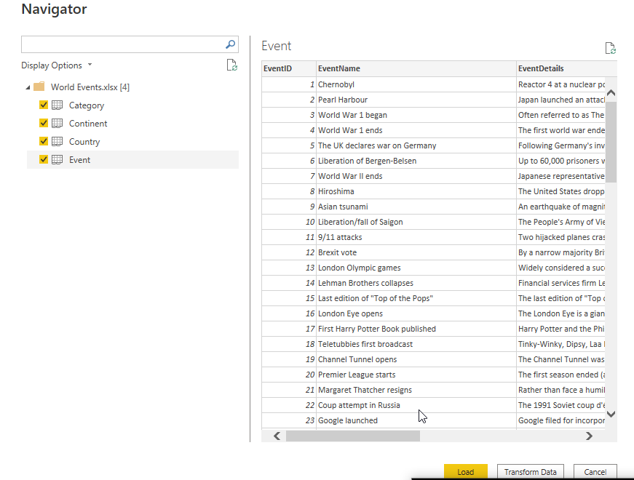

Step-1: In model section make necessary relationship as shown in below. Always place facts table below dimension tables for better understanding.

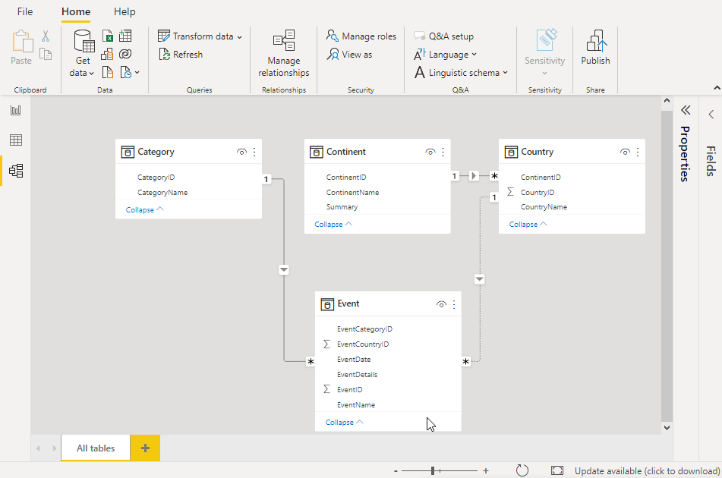

Step-2: Using RELATED DAX FUNCTION insert columns for category, country and continent in events table as shown below.

Country = RELATED (Country[CountryName])

Category = RELATED (Category[CategoryName])

Continent = RELATED (Continent[ContinentName])

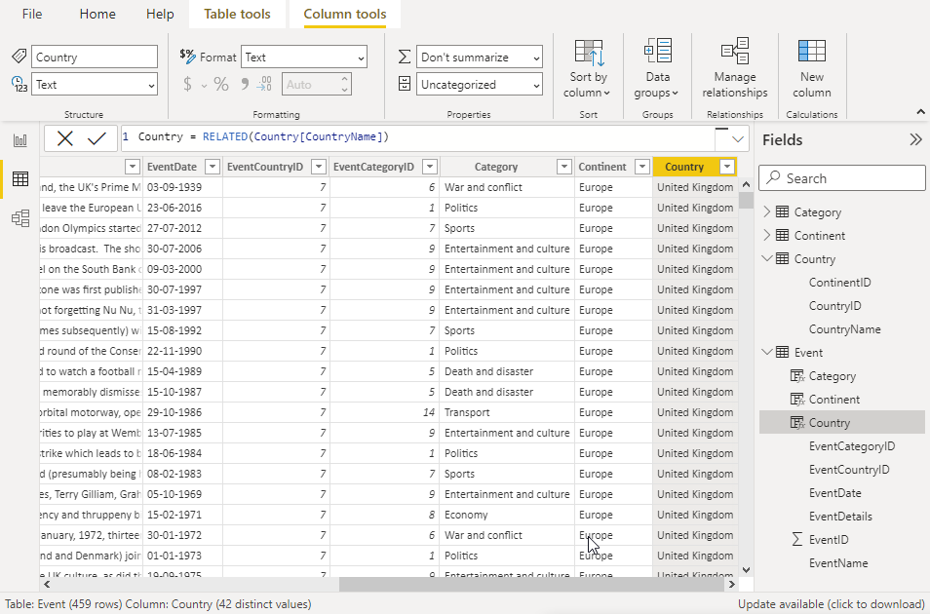

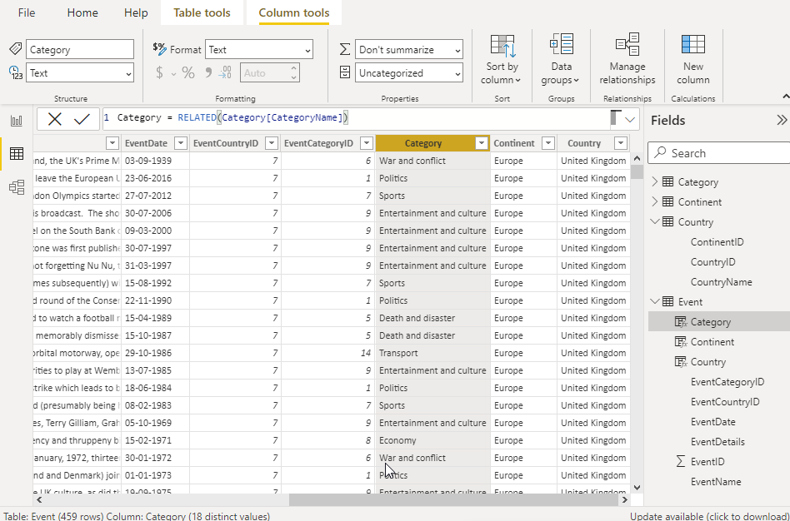

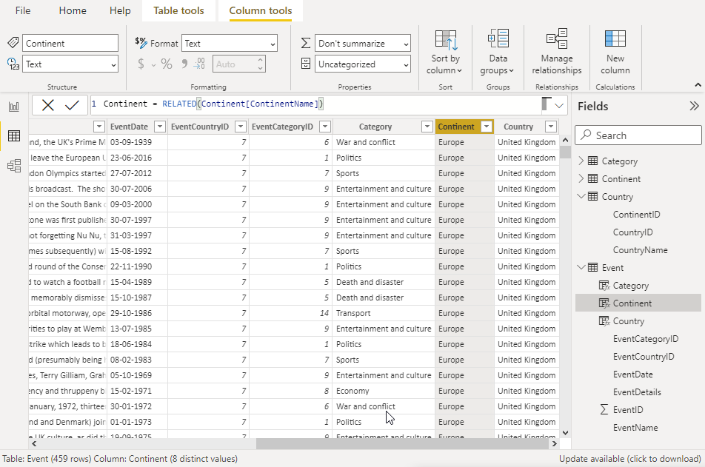

Step-3: Using Matrix visual to show the number of events and continent.

